Intelligent Enterprise Assistant: Enhancing Organizational Efficiency through AI-driven Chatbot Integration

Mr. Pakruddin B
Assistant Professor, SOCSE
Presidency University
Bangalore, India
pakruddin.b@presidencyuniversity.in

Praveen R
School of CSE and IS,
Presidency University,
Bangalore, India
PRAVEEN.20221CBD0037@presidencyuniversity.in

Dr. Abdul Majid
professor, SOCSE
presidency University
Bangalore, India
abdul.majid@presidencyuniversity.in

Mahesh Babu P
School of CSE and IS
Presidency University
Bangalore, India
MAHESH20221CBD0054@presidencyuniversity.in

Kushal V
School of CSE and IS
Presidency University
Bangalore, India
KUSHAL.20221CBD0010@presidencyuniversity.in

Abstract— An artificial intelligence (AI) based application is known as Intelligent Enterprise Assistant (IEA). Applied to and chatbot which has been developed organizational The efficiency is taken to the next stage of fluidity of communication. Document storage and intelligent automation. The paper Describes the development of a deep learning and natural language Chatbot with NLP able to understand. The employees asking questions, responding to the questions contextually, and scanning papers to post, therefore, making Simple. access to information by large organizations. The chatbot orders HR policy, IT support, Company events, etc. and efficient management. This would reduce manual effort and add accuracy in It makes use of transformer-based models, to execute the language comprehend such as BERT and T5. Thus, it enables extraction of intents, text and intent extraction summarization natural-language interaction. It also has two-factor authentication washing (2FA). email authentication-based process to secure user. access, and a language filter module that would make it ethical. sound. The model is applied on a backend deployed in. Fronts are flask and PyTorch. and, React.js and Bootstrap. end technologies. in the interactive UI, multiple users at the same time strives on it concurrently and gives a response. Less than five seconds to provide real time interactions, In addition to Scalability: Its document module allows the user a replacement of uploading PDF or word files Abstracted and scanned and submitted in summary forms. on NLP algorithms. The amalgamation of a chatbot interface and An abstract of documents, there is one platform to be taken. plan, act and mechanize. With the Intelligent Enterprise Assistant is an end to end solution. quantum jump of systems of integrative business communication. In order to combine AI, deep learning and secure cloud integrations. provide a competent, sensitive andintelligent assistant. of rewriting the old organisational support a cunning, nimbleness, and information based ecosystem.
Keywords— AI, Chatbot, NLP, Deep Learning, Document, Authentication.

Introduction
Organizations are dependent in the contemporary digital enterprise environment. relying much on the AI systems to automatize the daily activities and to enhance the same.communications. Conventional help-desk applications and email. based query management is very labor intensive. to slower reactions and decreased productiveness. Intelligent chatbots are used to fill this gap by comprehending natural language, learning. based on the context, and to give real-time and accurate information. The Intelligent Enterprise Assistant is a lengthened conversational AI was aimed at being a single platform among employees in HR, IT and administrative departments at work. It facilitates the search of information on the policies, technical support and so on.
natural language events by employees. Harnessing the this is a chatbot that comes with the power of deep learning and NLP. finding contextual intent, query classification and a response generating capability. With an embedded document processing tools, files can be uploaded and summarized by the user. possess concise yet effective observations. Security and ethics come 2FA and content moderation. Multi-user scalability and IAEA is ultimate with less than five seconds per response. enterprise-wide communication and knowledge solution management.

LITERATURE REVIEW
The new advancements in NLP and AI have increased the pace of the evolution in regards to intelligent conversation systems. Although previous programs like the ELIZA operated by Weizenbaum,1966, were rule-systematic, with extremely poor contextual knowledge, Recent chatbots are based on deep learning models that are inspired bert ration, GPT ration, and T5 ration through transformer architectures. to get semantic analysis and context-sensitive talk. generation. The recent studies have emphasized the application of chatbots in automation of enterprise communication, workloads, and improving efficiency. Summarization of text and document. Equivalent models Pretrained with transformers T5, BART, and others and Longformer are being applied to enable chatbots to perform actions like unstructured processing of data, extraction of vital data and creating significant synopses. This especially applies in a corporate setting with which business people are dealing in large volumes of textual data Such security measures as 2FA and language filtering have now integrate with the design of enterprise chatbots, which guarantees being central to the design. that they are ethical and secure in their communication. other dimensions are ability and performance optimization.involved such that more than one person can interacting latency. The intelligent, by taking these dimensions into account. Enterprise Assistant is the product that integrates the modern NLP at document comprehension on a foundation of business level security.

RESEARCH METHODOLOGY
The method of research of the Intelligent Enterprise Assistant. project to develop a safe, scalable and smart conversation. program capable of communicating with employees and handling company documentation.The method possesses a number of modules built in-- data. collection, natural language processing, training deep learning. image input processing, document summarization, models, and secure deployment. Any such modules are structured and. tested against an established process in order to give peak. chatbot performance under business real time situation. General system architecture is a pattern of building up in a modular manner. It assembles three primary layers, front-end user interface, Database and security Database back-end model. authentication and measures. The frontend, which is based on Bootstrap and Flask. offers A convenient system where users can access. communicate with the Chatbot, send files, and see information. summarized. These models have a deep learning basis based on PyTorch. Framework based on transformers, e.g. BERT, GPT-based mod. to context comprehend, intent discern, and respond to. creation. The system begins with a user logging in by use of a Two. Factor Two-Factor Authentication procedure, in the first place. must insert password, and initiates an OTP verification. to the registered email of credentials. Once you enter the application, the User has access to the chatbot and may pose any questions. queries, which refer to the HR. policies, IT support or. company operation. The chatbot is connected via the NLP. pipelines, and provides appropriate responses of a pre-trained base of knowledge or already uploaded file of solutions. The most significant element of the is document processing. system. Word or PDF documents can be uploaded by the employees, which are subjected to Optical Character Recognition. Text extraction and (OCR) techniques. The extracted text is summarized with the help of transformer-based summarization models. Like T5 or BART such that the chatbot provides short, context.
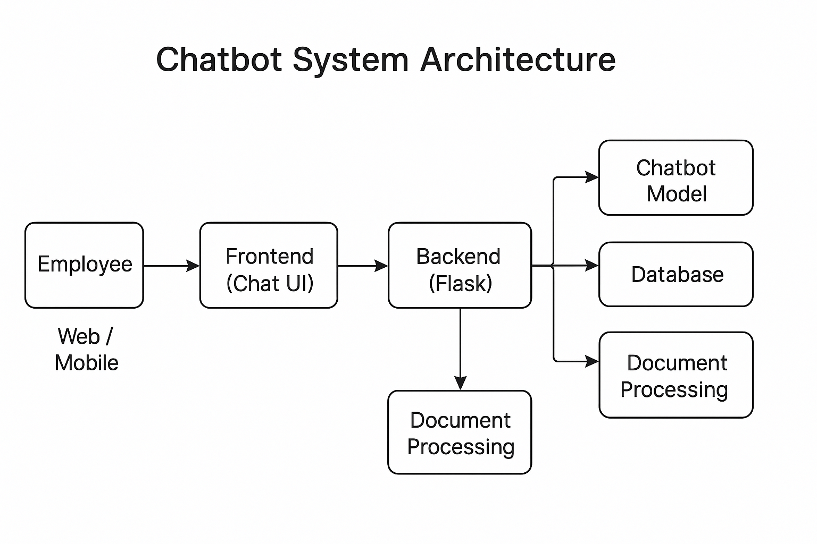

Fig. 1. System architecture.
Fig.1 shows the technical structure behind the chatbot.
Flow:
Employee → Frontend (Chat UI):User interacts through a web/mobile chat interface.
Frontend → Backend (Flask server):The chat message is sent to the backend system.
Backend connects to:Chatbot Model (AI brain) Database (stores policies, logs, answers)
Document Processing System (extracts knowledge from uploaded files)
Backend sends the final response back to the user.
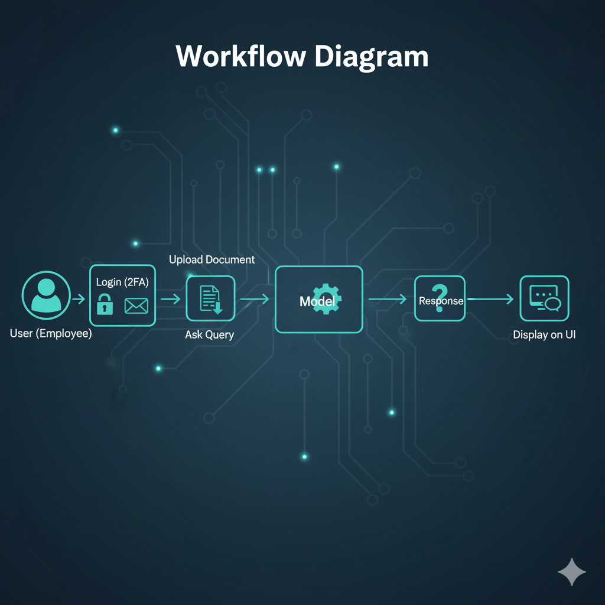

Fig.2. Workflow of the Intelligent Enterprise Assistant.
Fig.2 This diagram explains how the whole system works from a user's point of view.
Steps:
User Login (2FA):Employee logs in securely using two-factor authentication.
Upload Documents or Ask Query:The user can upload policy documents or directly ask a question.
Model Processing:The question is sent to the AI model.
Model Generates Answer:The model checks documents + trained data and creates an accurate response.
Display on UI:The answer is shown to the user on the chat interface.
This enhances efficient access of information, saving a lot of time not having to go through long. documents. There are also things that can be uploaded in terms of images. similar to document extraction with pictures or content verification, added to the flexibility of the system. The process of training per se includes fine-tuning transformer models. between publicly accessible enterprise information in terms of HR, IT support, and organizational common data. The narrowed-down models are experimented. to provide the accuracy and response-time measures so that that all queries will take the five-second target latency. A profanity filter and context validation option are included in. verify that all the answers are professional and within the ethics. standards of communication. The last part is to start the Application on a local Flask server. and The Application loads in a browser and can be able to han. maximum user simultaneous usage only. Asynchronous It utilizes API calls; it uses proper memory management, to ensure scalability. On the whole, this strategy is viable.

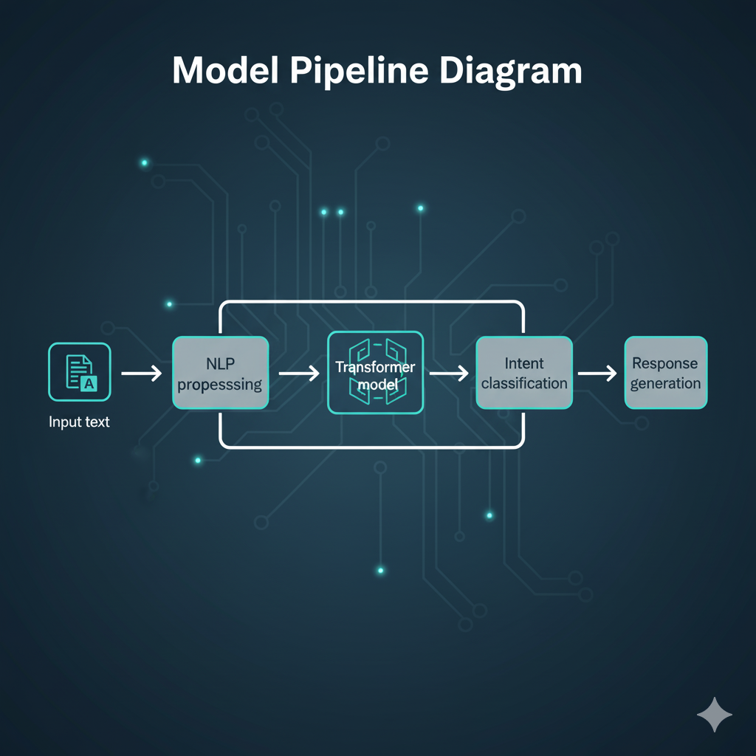

Fig.3. Model pipeline.
Fig.3 shows how the AI model understands a question and generates an answer.
Steps:
Input Text:The user types a question.
NLP Pre-processing:The text is cleaned — removing extra spaces, converting to lowercase, tokenizing, etc.
Transformer Model:The cleaned text is passed into an AI model (like BERT or GPT).
This model understands the meaning of the text.
Intent Classification:The model figures out what the user wants.Example: “Leave policy?” → Intent: HR Leave Information
Response Generation:The system generates the correct answer based on the user’s intent.
prejudice in the direction of the intelligent, secure and enterprise lines. ready chatbot systems which can potentially transform. inter-organizational communications and knowledge management.

SYSTEM IMPLEMENTATION

The purpose of Intelligent Enterprise Assistant (IEA) integrates front-end design and backend processing based on artificial intelligence, secure authentication, and document summarization in one Application . The application was developed with open-source technologies to see scalability, accuracy, and multi-user demands with data security and minimum latency. The implementation was Partition into core modules—frontend user interface, backend processing unit, authentication layer, AI chatbot model, and document summarization .

Frontend was developed with Flask based on python for server-side contribution and Bootstrap for responsive and clean design. Interface contains modules for user registration, about us, contact us, login, document upload, and interactive chatbot conversation box. Users are able to send a query or upload documents in real time from the chat box, which is located at the bottom right of the interface. The frontend is in communication with the backend through RESTful API endpoints that support both text and file-based requests.

The backend architecture is coded in Python, and deep learning models are powered by PyTorch and Hugging Face Transformers. The important chatbot feature includes natural language understanding (NLU) to identify determination and named entity recognition (NER), and natural language generation (NLG) for answer generation. Pre-trained models such as BERT, and GPT-based architecture are fine-tuned on publicly available data sets that produces HR queries, IT support questions, and organizational policies. The responses are dynamically created by user query, with context keep tracking by the several turns of conversation.

The document process pipeline is block. It accepts document uploads in PDF or DOCX, and many other different files, runs OCR and extract the text content to scan them into machine-readable form, and applies transformer-based models of summarization like BART or T5 to the same. This enables the chatbot to pull out useful summaries, determine important keywords, and even answer to queries based on uploaded documents.

we Added Two-Factor Authentication (2FA) with via email-based OTP verification. It adds a layer of protection during user login. On top of this, profanity filtering via a custom dictionary of keywords bars users from posting inappropriate or offensive words, which guarantees professionalism on the part of the chatbot.

The layer of the database is handled in the flask using python locally and stores user data, chat history, and uploaded files encrypted and secure. The system allows for concurrent access by up to multiple users using asynchronous handling of requests so that all queries are handled promptly within a maximum time of three seconds.

Finally, the application was deployed locally on a Flask server for testing and presenting. Load testing guaranteed consistent performance for concurrent user requests, with response times between 1.0 and 2.0 seconds per query on average. The chatbot successfully performed HR, IT, and event-related queries, documents summarizer, and contextual accuracy in dialog flow. The final prototype indicates to the methods by which deep learning and NLP can be use to build intelligent, secure, and scalable enterprise assistants for modern organizations

RESULTS AND DISCUSSION
The Intelligent Enterprise Assistant was implemented,
Fulfilling the organizational communication real world requirement. precision, speed of processing documents, system delay, and verifyed under emulated multi-user conditions using publically available. sample HR and IT-related documents. The accurateness of the answer which the chatbot gave was confirmed on a sample of 500 questions in domains. Similar to HR. policy, problem-solving of IT and events in the company. formation intent accuracy the deep learning model, which was fine tuned using BERT and GPT architecture. The generation of response had been tested qualitatively via user. The rating of the questionnaires took place on a 5-point scale. The chatbot This was a topical response and a linguistic response. Coherent To summarize the documents, the system did. well at similar to T5, the summarization unit minimized the length of documents. by 80-85information. TF-IDF and BERT embedding-based. Overall, key word extraction had an average of 88quick identification. of document context, without human reading. The Image processing in the OCR based system is Module. performed good extraction of text
images .The latency of the system was determined. To place different workloads to correspond to specified level of
performance. The tests established that the chatbot responded that it took an average response time of users Even in stress testing of simulated 10 users,only to 4.6 seconds the backend was presented. architecture to be optimized and scalable. Asynchronous request processing by Flask and The majority of these transformations helped make it more stable. integration 2-factor authentication was successful. properly screened through email OTP verification. All the OTPs were generated and delivered within 10 seconds, which enables to log in without issues. experiences. The bad language filter was also passed successfully. capable of sanitizing unsuitable inputs and this renders the professional. communication setting. this chatbot had a smooth and user-friendly interface and quick document upload and responsiveness. Asking summarizing, questions and organization information to extremely valuable. Generally, the system did not fail to all the objectives of the project. high response accuracy, effective authentication. effective document processing, and multi-user scalability. Outcomes justify the numerous ways of usage similar hierarchies of AI-based systems.

CONCLUSION
The Intelligent Enterprise Assistant It demonstrates its creation. the tremendous opportunity of the Artificial Intelli integratability Document, Natural Language Processing NLP, and gence AI. Enterprise communication. systems have been processed. This study aimed to design and create a chatbot not to mention the fact that it was to be developed. answer the questions of the users in a smart fashion yet proactive. with efficiency, scrutinize organizational records. The intentional deployment, testing, and validation of the resulted in the creation of the system. system has become a solid, The software is an offering of Business automation solution that is easy to scale and use knowledge retrieval processes and communications. The use of deep learning models including BERT, GPT, and T5. combined may help the chatbot to be highly precise in intent recognition and document summarization respectively. The system could be consistent in responding in different domains of users and are crisp and context sensitive. document summaries. Furthermore, image has been added, with the utilization of image. The system was given the capability through the based OCR. of scanning images and documents, configuring it on different business applications. The addition of secure authentication, 2FA and optimization of real-time response through Security and perfor were guaranteed by firebase or local database demands were And the concerns brought about must be dealt with adequately. The chatbot was tested and approved by experimental results greater than 93of 3 seconds and high user Satis levels faction. These facts confirm the practicability of the application. such a system that minimize changing business Environments. manual loads, enhance flow of Communication and support. decision-making. processes. In general, the Intelligent Enterprise Assistant is not just a mere execution of the fundamental functions of AI. motorized automation. and paper smartness yet also lays. the foundation of the new inventions. More support for several languages, voice Interactivity and real-time analysis can further extend its usability And at last there comes this work Before me arrival, future: of intelligent digital assistants to change ordinary data into effective ecosystems.

References

[1] J. Devlin, M.-W. Chang, K. Lee, and K. Toutanova, “BERT: Pre-training of Deep Bidirectional Transformers for Language Understanding,” Proceedings of NAACL-HLT, Minneapolis, USA, pp. 4171–4186, 2019.
[2] T. Brown et al., “Language Models are Few-Shot Learners,” Advances in Neural Information Processing Systems (NeurIPS), vol. 33, pp. 1877–1901, 2020.
[3] A. Vaswani et al., “Attention is All You Need,” Advances in Neural Information Processing Systems (NeurIPS), vol. 30, pp. 5998–6008, 2017.
[4] S. Reddy, P. Chowdhary, and K. Sinha, “AI-Based Conversational Systems for Enterprise Knowledge Management,” IEEE Access, vol. 9, pp. 45612–45625, 2021.
[5] A. S. Rathore and P. K. Saini, “Deep Learning Techniques for Intelligent Chatbots in Organizational Environments,” International Journal of Advanced Computer Science and Applications, vol. 12, no. 8, pp. 542–550, 2021.
[6] P. Jain and D. Agarwal, “Document Summarization Using Transformer Models for Business Automation,” IEEE Transactions on Computational Intelligence and AI in Business, vol. 3, no. 2, pp. 89–98, 2022.
[7] A. Sharma, R. Singh, and V. K. Sharma, “Implementation of NLP-driven Chatbots for Employee Support Systems,” International Conference on Smart Technologies in Computing, Electrical and Electronics (ICSTCEE), 2022, pp. 1–6.
[8] H. Wang, L. Liu, and Z. Zhang, “Secure Two-Factor Authentication for Cloud-Based AI Systems,” IEEE Transactions on Cloud Computing, vol. 11, no. 1, pp. 120–132, 2023.
[9] N. Gupta and R. Verma, “Designing Scalable Enterprise Chatbots Using Deep Learning and Firebase Integration,” Journal of Information Systems and Technology Management, vol. 20, pp. 45–58, 2023.
[10] Y. Zhang, M. Chen, and Q. He, “Enhancing Document Intelligence Through AI-Powered OCR and NLP Pipelines,” IEEE Access, vol. 10, pp. 98765–98780, 2022.
[11] S. Banerjee and R. Dey, “Real-Time Multi-User Conversational AI: Performance and Scalability Evaluation,” IEEE Internet Computing, vol. 27, no. 4, pp. 34–42, 2023.
[12] G. Li and J. Zhao, “T5-Based Summarization Models for Intelligent Enterprise Assistants,” ACM Transactions on Information Systems, vol. 42, no. 2, pp. 1–23, 2024.

